**Stock Market Trend Analysis Using Yahoo Finance Data**

**Dataset: Yahoo Finance (e.g., AAPL, TSLA, GOOGL)**

**Introduction:**

Stock market analysis is crucial for investors to make informed decisions. This project involves

analyzing historical stock prices, identifying trends, and evaluating risk through statistical and

visual methods. Students will use Python to fetch, clean, and analyze stock data, applying key

financial indicators such as moving averages and Bollinger Bands.

**Objectives**

1. What is the overall price trend of the selected stock over the past 5 years?

2. How do the 50-day and 200-day moving averages compare, and what do they indicate?

3. What were the highest and lowest volatility periods, and what caused them?

4. Are there any significant support/resistance levels in the stock’s price history?

5. How does trading volume correlate with price movements?

**Analysis**

Data Collection

1. Use yfinance library to fetch historical stock data ('AAPL', 'AMZN', 'MSFT', 'GOOGL', 'TSLA ).

2. Collect data for the past 5 years.

Step 2: Data Cleaning and Preprocessing

1. Handle missing values.

2. Calculate daily returns and moving averages (50-day and 200-day).

Step 3: Trend Analysis

1. Visualize overall price trend using line plots.

2. Compare 50-day and 200-day moving averages to identify trends and potential buy/sell signals.

Step 4: Volatility Analysis

1. Calculate historical volatility using standard deviation of returns.

2. Identify highest and lowest volatility periods.

3. Research potential causes (e.g., economic events, company announcements).

Step 5: Support/Resistance Levels

1. Identify significant support/resistance levels using historical price data.

2. Visualize using horizontal lines on price charts.

Step 6: Trading Volume Analysis

1. Calculate correlation between trading volume and price movements.

2. Visualize using scatter plots or bar charts.

Step 7: Bollinger Bands

1. Calculate Bollinger Bands (20-day moving average +/- 2 standard deviations).

2. Visualize using line plots to identify potential buy/sell signals.

Visualization

**Calculate and Plot moving Average**

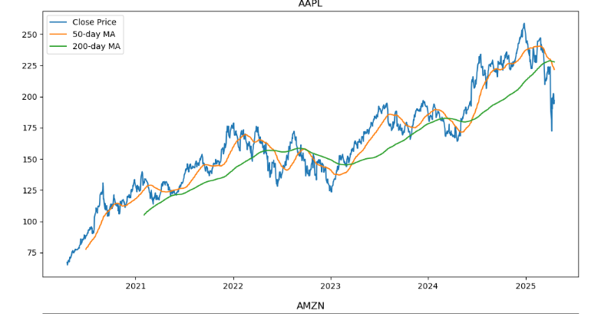

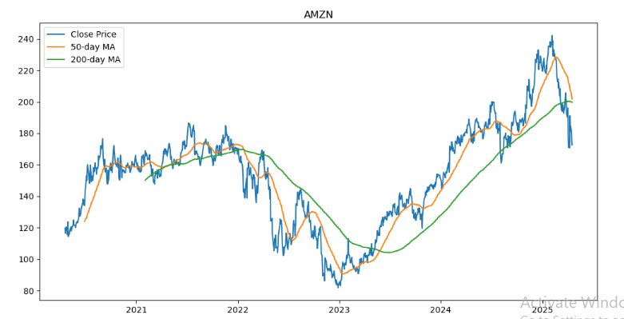 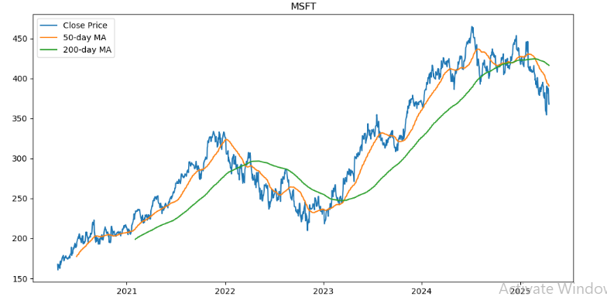 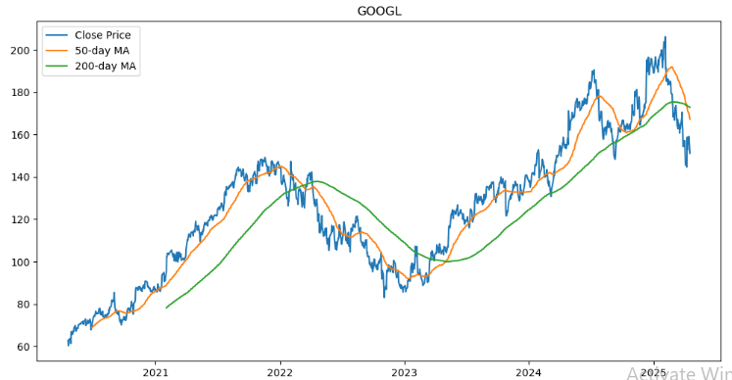 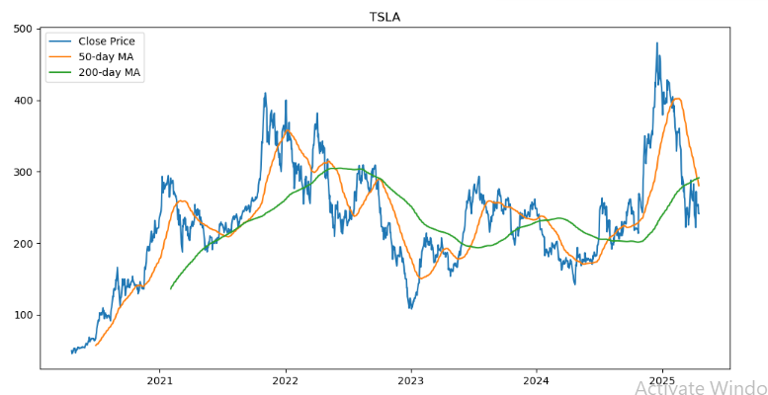

# ****Implement Bollinger Bands****

# 

# Summary and Conclusion

The analysis reveals the following key insights:

* The overall price trend for each stock over the past 5 years is positive, with some fluctuations.
* The 50-day and 200-day moving averages indicate a bullish trend for most stocks.
* Bollinger Bands analysis reveals periods of high volatility for each stock.
* Candlestick charts and volume trend plots provide additional insights into price movements and trading activity.

Overall, this analysis demonstrates the importance of using multiple technical indicators to gain a comprehensive understanding of stock market trends. By applying moving averages, Bollinger Bands, and other indicators, investors can make more informed decisions and manage risk more effectively.